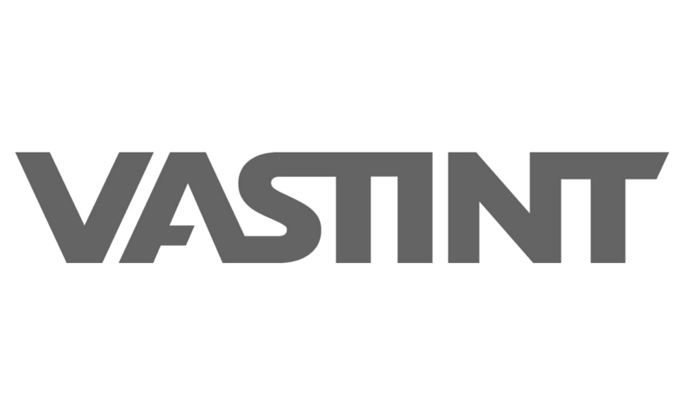
DPIA PROCEDURE AT VASTINT
Data Protection Impact Assessment workflow

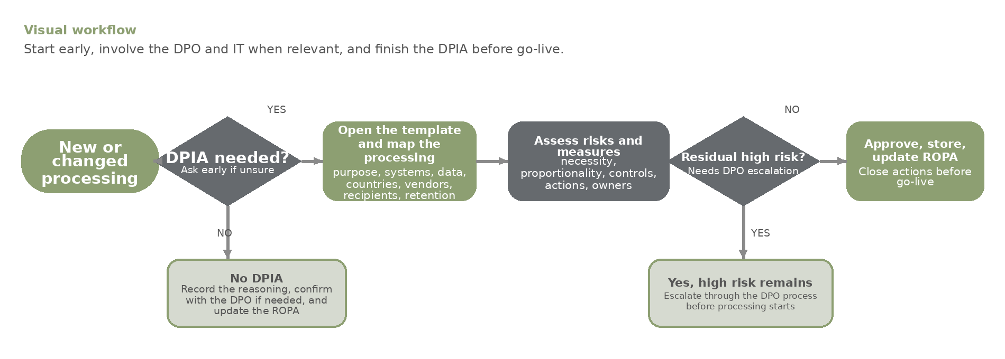
When to start  • Fill-in and document Pre-DPIA Checklist  • New tool, website, process, vendor, CCTV set-up, or material change using personal data.  • Sensitive data, profiling, monitoring, large-scale use, or new transfers/recipients.  • If unsure whether a DPIA is needed, ask privacy@vastint.eu early. | Templates and filing  • Use the Interogo Personal Data Protection Manual and Templates.  Teams > Privacy Champions Team > General > Privacy & Procedures Templates  • Store final DPIAs in Assessments & Reports and update the Record Of Processing Activities. | Questions?  privacy@vastint.eu  lucas.noronha@vastint.eu

